Supporting Information
Effect of Bromine Doping on Charge Transfer, Ion Migration and Stability of the Single Crystalline MAPb(Br_{x}I_{1−x})₃ Photodetector
Apurba Mahapatra,ª Daniel Prochowicz,^{b,}* Joanna Kruszyńska,^{b} Soumitra Satapathi,^{c} Seckin Akin,^{d} Hemant Kumari,^{e} Pawan Kumar,ª Ziba Fazel,^{f} Mohammad Mahdi Tavakoli^{g,}* and Pankaj Yadav^{e,}*
ª Department of Physics & Astronomy, National Institute of Technology, Rourkela, 769008, India,
^{b} Institute of Physical Chemistry, Polish Academy of Sciences, Kasprzaka 44/52, 01-224 Warsaw, Poland.
^{c} Department of Physics, Indian Institute of Technology Roorkee, Roorkee, Haridwar, Uttarakhand 247667, India.
^{d} Department of Metallurgical and Materials Engineering, Karamanoglu Mehmetbey University, 70200 Karaman, Turkey.
^{e} Department of Solar Energy, School of Technology, Pandit Deendayal Petroleum University, Gandhinagar-382 007, Gujarat, India.
^{f} Electrical Engineering Department, Sharif University of Technology, Tehran, 11365-11155, Iran
^{g} Department of Electrical Engineering and Computer Science, Massachusetts Institute of Technology, Cambridge, MA 02139, USA.

Corresponding authors: dprochowicz@ichf.edu.pl; pankaj.yadav@sse.pdpu.ac.in; mtavakol@mit.edu

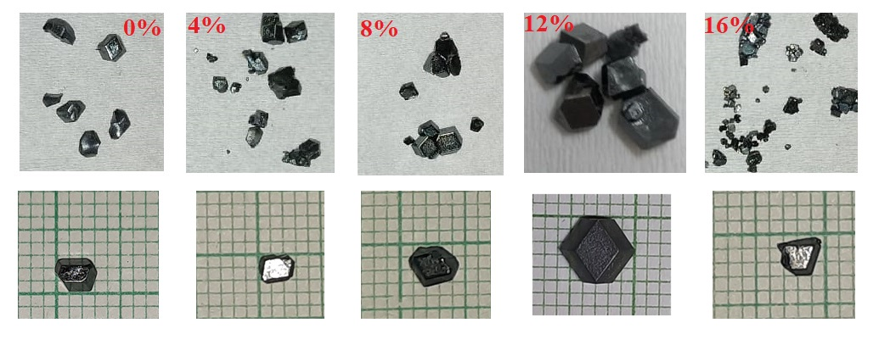Fig. S1. Photographs of the resulting MAPb(Br_{x}I_{1−x})₃ ( x = 0, 0.4, 0.8, 0.12, 0.16) SCs.

Fig. S2. EDX data for MAPb(Br_{x}I_{1−x})₃ ( x = 0.4, 0.8, 0.12, 0.16) SCs grounded powders.
Fig. S3. EDX mapping of Br doped SCs. SEM images of (a) surface (c) crushed to powder. Overall mapping elements on the same spot of (b) surface (d) crushed powder corresponding to iodide (red) and bromide (green). The scale bar is 10 μm.
Fig. S4. (a) Enlarged view of the XRD peak at around 28º. (b) XRD patterns of the 365 days aged MAPbI₃ and MAPb(Br_{x}I_{1−x})₃ grounded powders.

Fig. S5. Intensity comparison of XRD patterns of the fresh and 365 days aged MAPbI₃ and MAPb(Br_{x}I_{1−x})₃ SC grounded powders.

Fig. S6. Analysis of the full width at half maxima (FWHM) for the pXRD peak of fresh and aged MAPbI₃ and MAPb(I_{1-x}Br_{x})₃ grounded powders.
Fig. S7. Temperature-dependent EIS data of (a) MAPbI₃ and (b-e) MAPb(Br_{x}I_{1−x})₃ SCs in the frequency range of 1MHz to 1Hz. (f) Arrhenius plots of the try to escape frequency (f₀) vs. 1000/T of MAPbI₃ and MAPb(Br_{x}I_{1−x})₃ SCs (decreasing cycle).
Fig. S8. The temperature-dependent conductivity of MAPbI₃ and MAPb(Br_{x}I_{1−x})₃ SCs. E_{a} is the activation energy of ions (Arrhenius plot).

Fig. S9. I–V hysteresis plots of MAPbI₃ and MAPb(I_{1-x}Br_{x})₃ SCs.
Fig. S10. Dielectric constant (ε_{r}) of MAPbI₃ and MAPb(Br_{x}I_{1-x})₃ SCs in the frequency range of 10 kHz to 1 MHz.
Fig. S11. Current-voltage curves of (a) MAPbI₃ and (b-e) MAPb(Br_{x}I_{1−x})₃ SCs based planar-type PDs.
Fig. S12. Intensity-dependent photoresponse of (a) MAPbI₃ and (b-e) MAPb(Br_{x}I_{1−x})₃ SCs based planar-type PDs.
Fig. S13. Photocurents of MAPbI₃ and MAPb(I_{1-x}Br_{x})₃ SC based planar PDs at different wavelengths as a function of light intensity.

Fig. S14. External quantum efficiency (EQE) of MAPbI₃ and MAPb(Br_{x}I_{1-x})₃ SC based planar PDs at different wavelengths as a function of light intensity.
Fig. S15. Photocurents of MAPbI₃ and MAPb(Br_{x}I_{1-x})₃ SC based planar PDs at different wavelength as a function of light intensity.
Fig. S16. Normalized photocurrent under (a) red light (630 nm) and (b) white light at 10 mW cm⁻² as a function of time.
Fig. S17. Long term photocurrent of MAPbI₃ and MAPb(Br_{x}I_{1-x})₃ SC based planar PDs at different wavelength.
Fig. S18. Photoresponse of (a) MAPbI₃ and (b-e) MAPb(Br_{x}I_{1−x})₃ SCs based planar-type PDs under continuous operation.

Table S1. Halide percentage calculation incide crystals using EDX data.
Crystal Composition | Iodine (Atomic %) | Bromide (Atomic %) | Avarage Br percenrage (Atomic %)
MAPb(Br_{0.04}I_{0.96})₃ | 95.76 | 4.24 | 4.01%
 | 96.07 | 3.93
 | 96.13 | 3.87
MAPb(Br_{0.08}I_{0.92})₃ | 92.09 | 7.91 | 7.92%
 | 92.33 | 7.77
 | 91.91 | 8.09
MAPb(Br_{0.12}I_{0.88})₃ | 87.87 | 12.13 | 12.04%
 | 88.20 | 11.80
 | 87.82 | 12.18
MAPb(Br_{0.16}I_{0.84})₃ | 83.63 | 16.37 | 15.97%
 | 84.22 | 15.88
 | 84.34 | 15.66

Table S2. The calculated activation energies for MAPbI₃ and (b-e) MAPb(Br_{x}I_{1−x})₃ SCs.
Crystal Composition | From Conductivity |  |  |  | From EIS (decresing cycle)
 | Incresing cycle |  | Decresing cycle |  |  | E_{a}  (cubic)  (eV) | E_{a}  (tetragonal)  (eV)
 | E_{a}  (cubic)  (eV) | E_{a}  (tetragonal)  (eV) | E_{a}  (cubic)  (eV) | E_{a}  (tetragonal)  (eV)
MAPbI₃ | 0.52±0.012 | 0.35±0.011 | 0.53±0.007 | 0.34±0.012 |  | 0.52±0.008 | 0.34±0.007
MAPb(Br_{0.04}I_{0.96})₃ | 0.55±0.013 | 0.36±0.012 | 0.55±0.013 | 0.34±0.013 |  | 0.54±0.013 | 0.35±0.020
MAPb(Br_{0.08}I_{0.92})₃ | 0.58±0.016 | 0.37±0.018 | 0.57±0.010 | 0.38±0.016 |  | 0.57±0.009 | 0.39±0.038
MAPb(Br_{0.12}I_{0.88})₃ | 0.62±0.011 | * | 0.62±0.011 | * |  | 0.59±0.011 | *
MAPb(Br_{0.16}I_{0.84})₃ | 0.61±0.015 | * | 0.61±0.015 | * |  | 0.59±0.012 | *

